Activation Report
ASAP 7.0.2 – WASS1133, JAMU66
ASAP-ORIGIN

September 17th, 2018

Contents

1 Activation Orders: JAMU66 Originated by CIS 3
1.1 JAMU66 Service Orders 3
1.2 Activation Orders Origin Distribution 4
2 Activation Orders: WASS1133 Originated by CIS 5
2.1 WASS1133 Service Orders 5
2.2 Activation Orders Origin Distribution 6

Activation Orders: JAMU66 Originated by CIS

JAMU66 Service Orders

ORIGINATING CIS | TOTAL | PERCENTAGE | COMPLETE | FAILED | TIMEOUT
CIS_JAMAICA | 42927 | 74.95% | 33912 | 2665 | 6350
CIS_CAYMAN | 892 | 1.56% | 808 | 84 | 0
CIS_ANTIGUA | 968 | 1.69% | 917 | 51 | 0
CIS_ANGUILLA | 290 | 0.51% | 284 | 6 | 0
CIS_BARBADOS | 1192 | 2.08% | 1182 | 10 | 0
CIS_BVI | 675 | 1.18% | 674 | 1 | 0
CIS_DOMINICA | 4151 | 7.25% | 4137 | 14 | 0
CIS_GRENADA | 824 | 1.44% | 823 | 1 | 0
CIS_MNI | 93 | 0.16% | 82 | 11 | 0
CIS_SANTA_LUCIA | 1450 | 2.53% | 1425 | 25 | 0
CIS_ST_KITTS | 703 | 1.23% | 698 | 5 | 0
CIS_SN_VINCENT | 1323 | 2.31% | 1321 | 2 | 0
CIS_TKI | 1697 | 2.96% | 1215 | 440 | 42
OCA | 88 | 0.15% | 73 | 15 | 0
INTEGSSOFT | 0 | 0.00% | 0 | 0 | 0
CIS_172_21_64_99 | 0 | 0.00% | 0 | 0 | 0
ASAP TEST | 0 | 0.00% | 0 | 0 | 0
 | 57273 |  | 47551 | 3330 | 6392

Activation Orders Origin Distribution

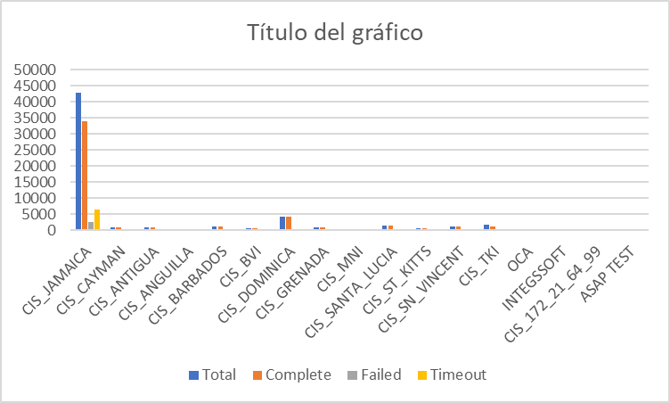

Activation Orders: WASS1133 Originated by CIS

WASS1133 Service Orders

ORIGINATING CIS | TOTAL | PERCENTAGE | COMPLETE | FAILED | TIMEOUT
CIS_JAMAICA | 15781 | 74.62% | 11568 | 2124 | 2089
CIS_CAYMAN | 0 | 0.00% | 0 | 0 | 0
CIS_ANTIGUA | 67 | 0.32% | 8 | 59 | 0
CIS_ANGUILLA | 139 | 0.66% | 103 | 36 | 0
CIS_BARBADOS | 0 | 0.00% | 0 | 0 | 0
CIS_BVI | 187 | 0.88% | 78 | 109 | 0
CIS_DOMINICA | 194 | 0.92% | 153 | 39 | 2
CIS_GRENADA | 1714 | 8.10% | 1606 | 105 | 3
CIS_MNI | 7 | 0.03% | 6 | 1 | 0
CIS_SANTA_LUCIA | 1926 | 9.11% | 1887 | 23 | 16
CIS_ST_KITTS | 232 | 1.10% | 171 | 61 | 0
CIS_SN_VINCENT | 651 | 3.08% | 618 | 33 | 0
CIS_TKI | 206 | 0.97% | 71 | 134 | 1
OCA | 5 | 0.02% | 5 | 0 | 0
INTEGSSOFT | 0 | 0.00% | 0 | 0 | 0
CIS_172_21_64_99 | 40 | 0.19% | 34 | 6 | 0
ASAP TEST | 0 | 0.00% | 0 | 0 | 0
 | 21149 |  | 16308 | 2730 | 2111

Activation Orders Origin Distribution

